VS Code Installation & Java + Selenium Setup Guide
Step 1:

- Download the VS Code installer from the official website (https://code.visualstudio.com).
- Run the downloaded installer file.

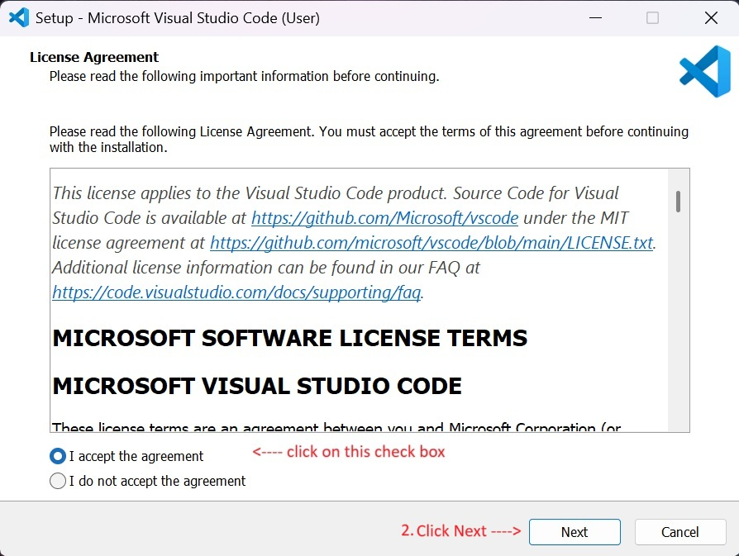

Step 2:
- Accept the license agreement.
- Click on Next to continue.
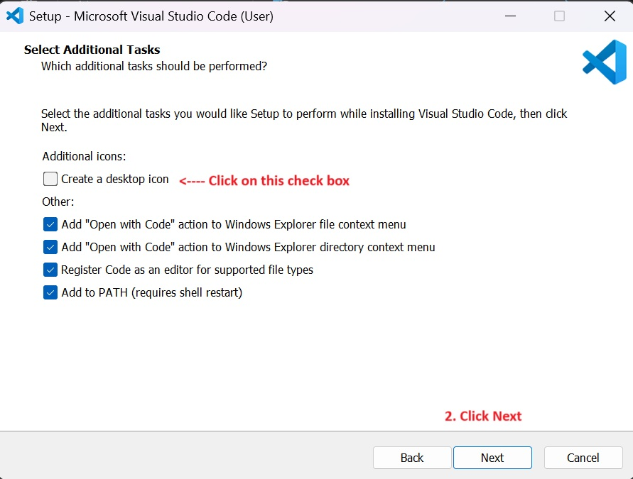

Step 3:
- Choose the destination folder where you want VS Code to be installed.
- Click on Next.
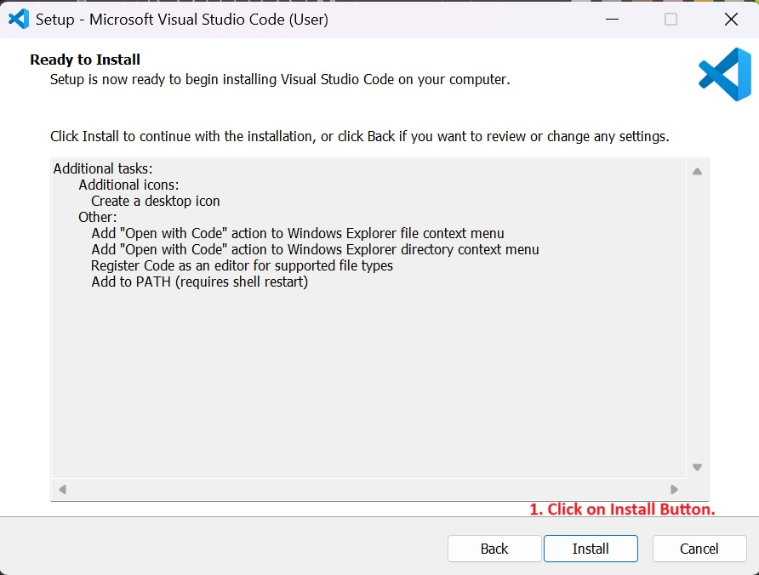

Step 4:
- Select additional tasks such as creating a desktop icon or adding VS Code to PATH.
- Click on Next.
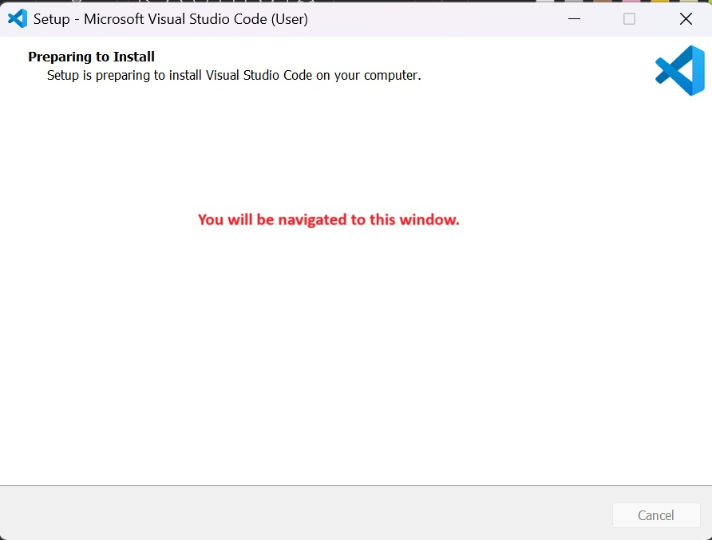

Step 5:
- Review your installation settings.
- Click on Install to begin installation.
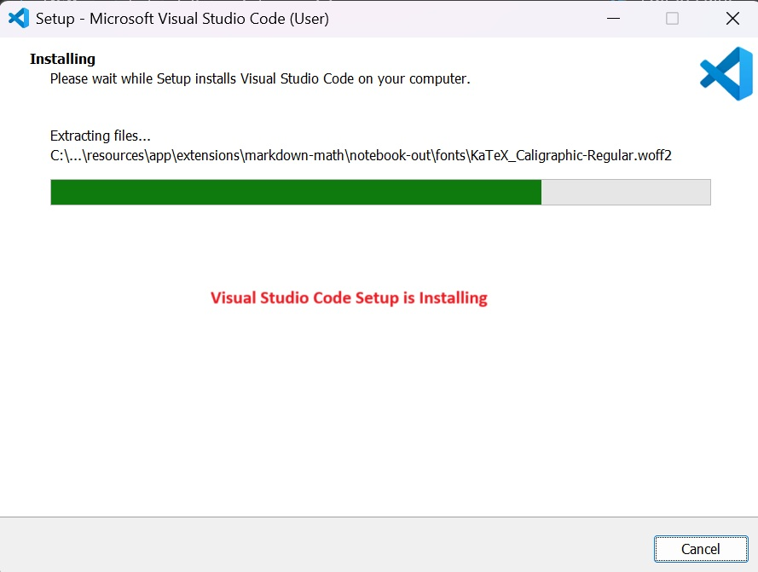

Step 6
- Wait for the installation process to complete.
- Click on **Finish** to launch VS Code.
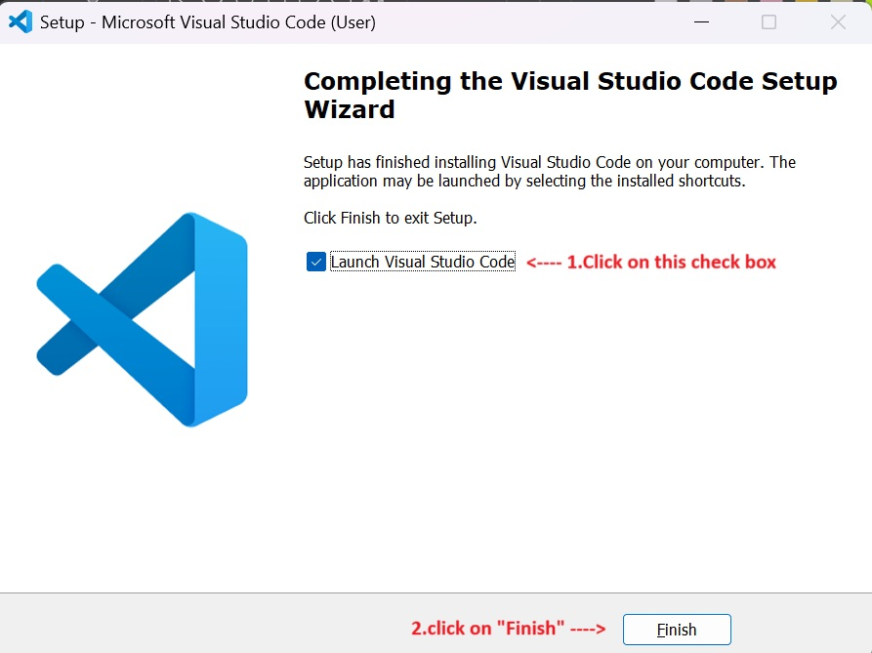

Step 7
- Download the VS Code installer from the official website (https://code.visualstudio.com).
- Run the downloaded installer file.
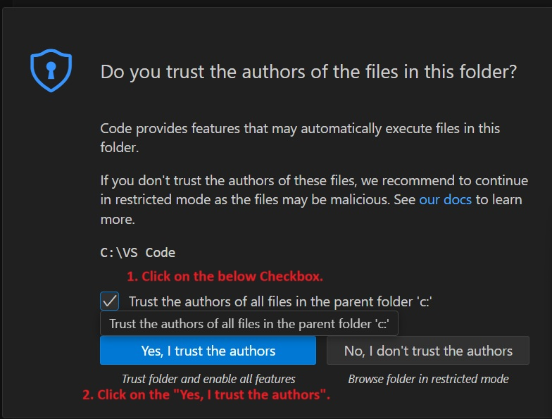

Step 8
- From the menu, go to **File → Open Folder**.
- Choose or create a new folder for your Java projects.
- Click **Select Folder**.
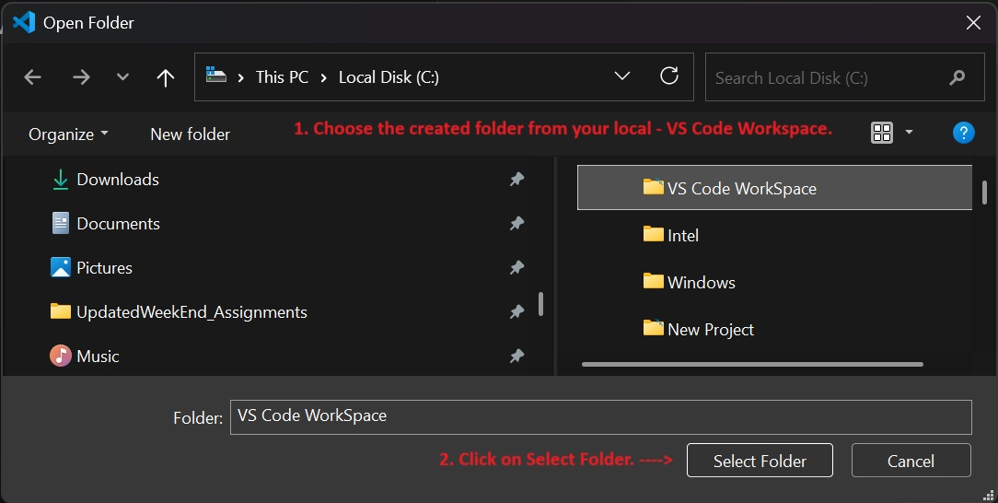

Step 9
- Press `Ctrl+Shift+P` to open the Command Palette.
- Type **Create Java Project** and select it.
- Follow the prompts to set up the project.
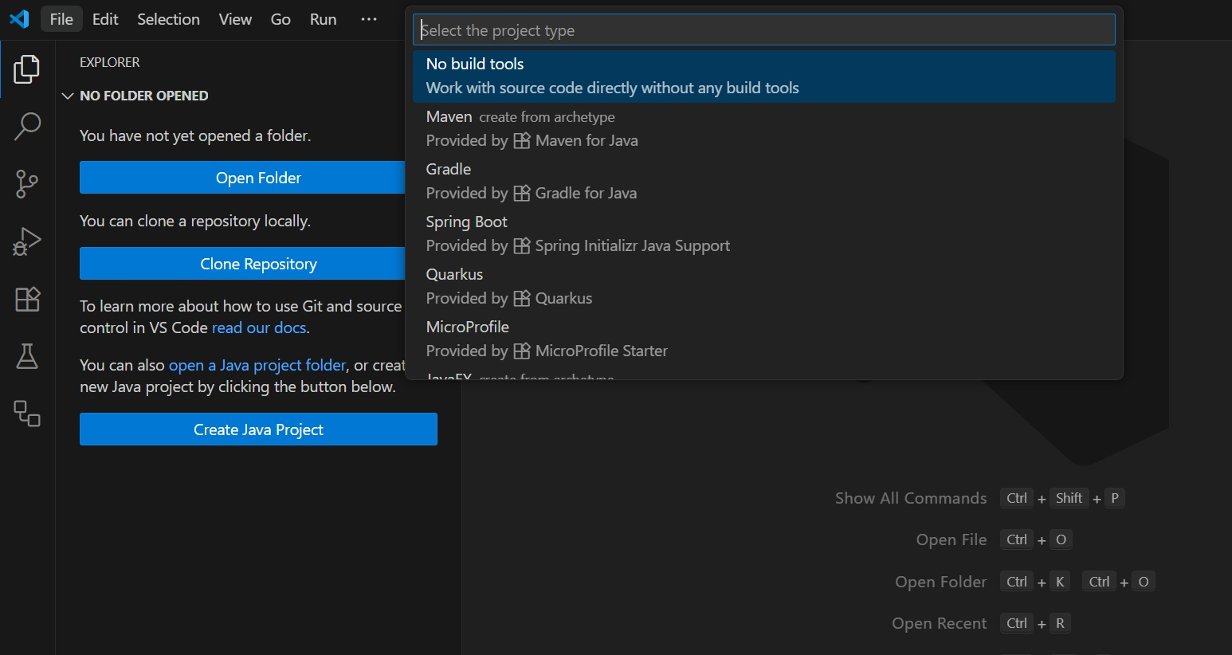
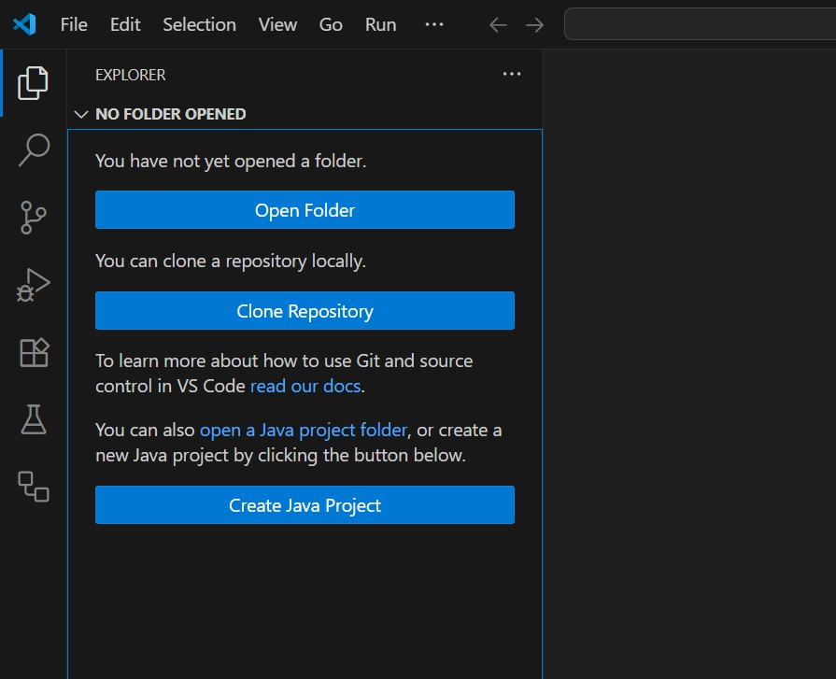

Step 10
- From the menu, go to **File → Open Folder**.
- Choose or create a new folder for your Java projects.
- Click **Select Folder**.
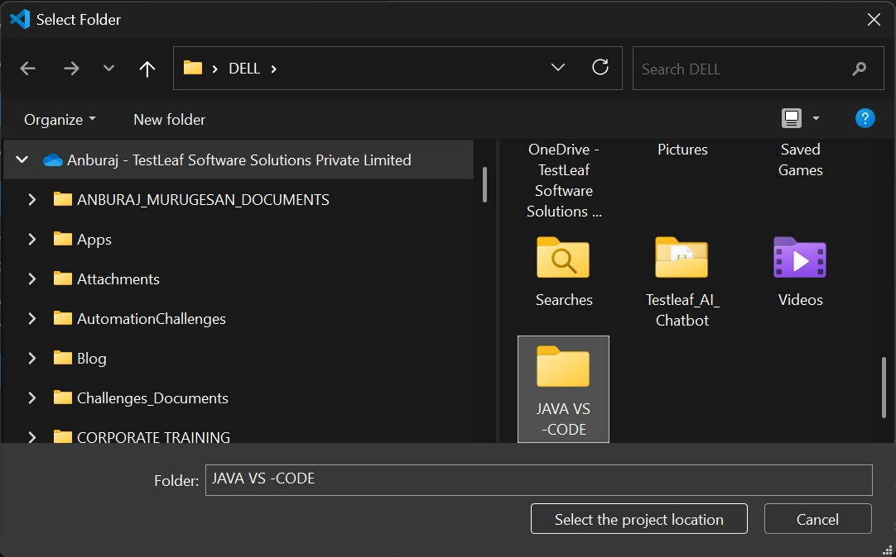

Step 11
- Your Java project has been created.
- You will see the `src` and `lib` folders in Explorer.
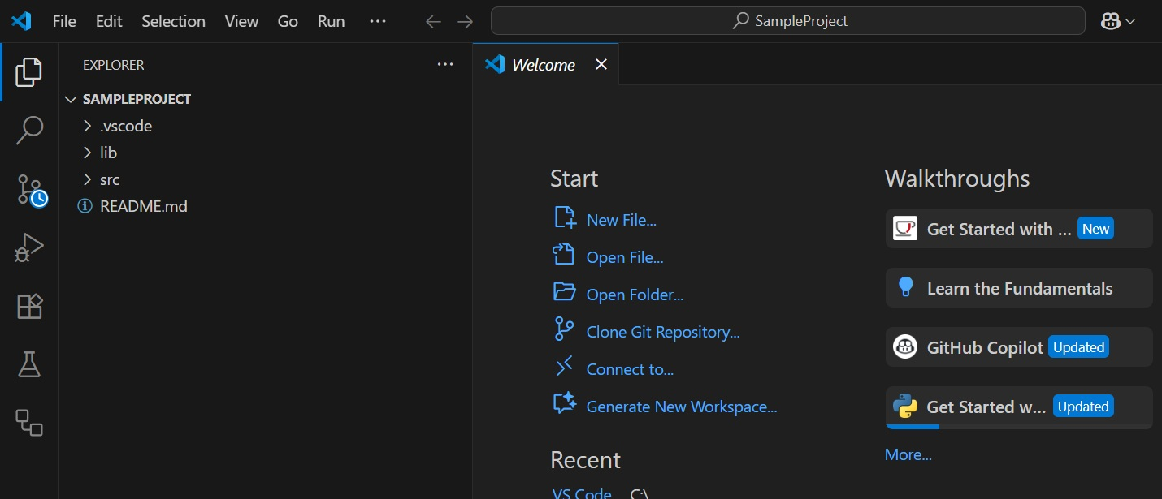

Step 12
- Open VS Code.
- Go to the **Extensions** view from the sidebar (or press `Ctrl+Shift+X`).
- Search for **Java Extension Pack**.
- Click **Install** to add Java support.
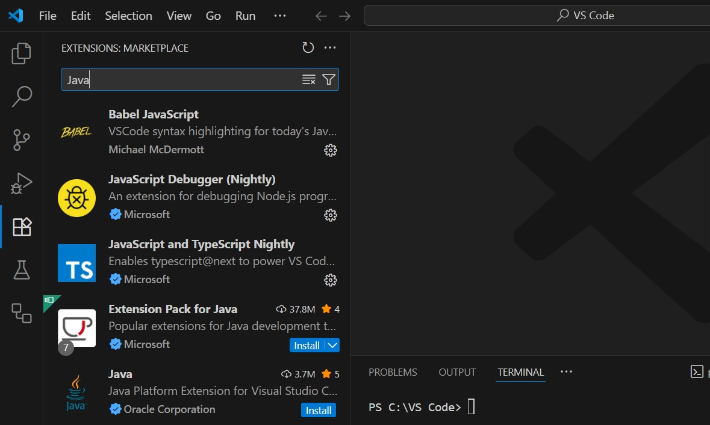

Step 13
- From the menu, go to **File → Open Folder**.
- Choose or create a new folder for your Java projects.
- Click **Select Folder**.
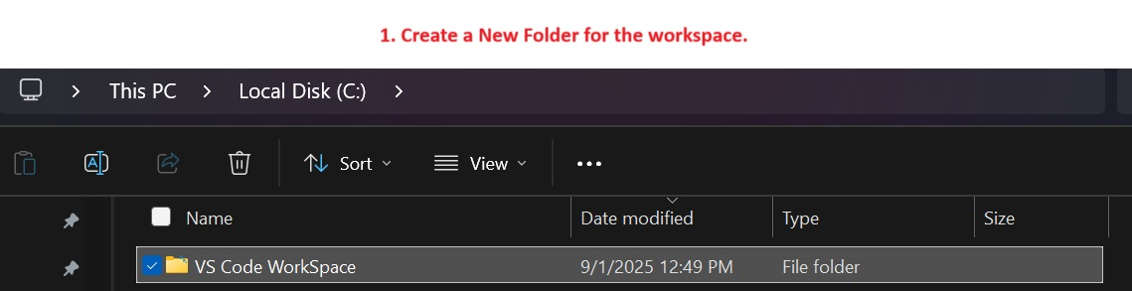

Step 14
- Enter your project name (e.g., `SampleProject`).
- Confirm to finish creating the project.
